Alan Craig - Bill Powell
Whilst I was writing and preparing the tribute to the late Bob “Bluey” Valentine for our last April Newsletter, I was astonished to learn the inspiration and encouragement that Alan Craig had exhibited in commencing Bob’s speedway career. This behaviour and assistance was also shown to many other speedway riders starting in the sport.
Alan was also involved in promoting and sponsoring speedway events and tracks. A remarkable man who, I feel, has not been acknowledged or credited for such.
Alan is an amazing part of the history of motorcycling in the Lake Macquarie, Newcastle, Hunter Valley region and beyond. A business leader and living legend in motor sports locally and nationally.
In his early days he was also successfully involved in car racing but this article is confined to his motorcycling career. Alan had reasonable success racing short circuit/dirt track at local tracks, including Muswellbrook (Hill View), Salty Creek and Heddon Greta and he was an A Grade rider.
Alan Hogan wrote a biography of Alan Craig’s life. In 1967 he opened his motorcycle shop at Boolaroo, originally selling Suzikis supplied by Hazel and Moore and Hondas from Bennett Honda.
Late 1969 was Craig’s introduction to speedway as he sponsored Bob Valentine at the Morisset speedway which was also sponsored by Alan Craig Suzuki. Morisset speedway was located 50 kms south of Newcastle and 120 km north of Sydney. The half mile circuit was opened in 1968 and closed in 1980.
In 1969 the solo one-lap track record was held by John Langfield (Eso) at 19.5 and the three-lap record was held by Trevor Harding (again Eso) at 60.1. With Sunday afternoon meetings, many competitors who had raced at the Sydney Showground on the Saturday night, would also travel to Morisset for the Sunday afternoon meeting.
Bob Valentine and Gary Buchaman shared a JAP machine in separate races – such was the camaraderie in those days, not to mention economic necessity. As luck would have it, a nasty crash put an end to the old JAP, so Alan bought Bob a brand new Jawa speedway bike so that he could continue his career.
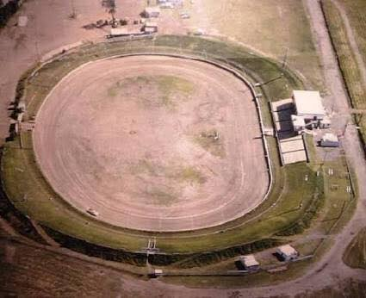
It was at Jerilderie Park at Tomago, north of Newcastle that he organised the first solo speedway meeting in January 1970 and continued to run the solo section through to 1974. He teamed up with Terry Dangerfield and leased the speedway until December 1976. Jerilderie Park was later known as the Newcastle International Motordrome and the Winfield Motordrome (in honour of heavy sponsorship from the Winfield cigarette brand) before changing the name again to a simpler Newcastle Motordrome. The track length was 400 metres and the surface was a clay base/decomposed granite.
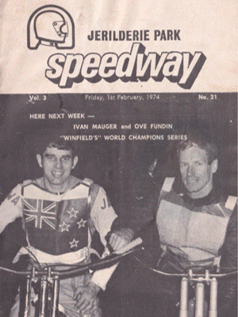
During these years they organised many solo tests and championship events for both solos and sidecars as well as hosting the American Sedan Teams for a number of years. Alan worked closely with six times kiwi world speedway champion, Ivan Mauger in promoting tests and international meetings. Some of the events of note at Jerilderie Park during Alan’s reign included the very popular event consisting of rounds of the Solo Teams Challenge in 1972. These comprised the Jayes Jetset Travel Centre (sponsors) versus Owen Craig Monarchs. Another being the Dirt Track Carnival in June 1976 for solos and sidecars - a 50-event program including handicap races. Of the one hundred A, B and C Grade competitors raced, with locals Keith Davies and Greg Primmer leading the list. A number of rounds of the NSW Junior Solo Championship were held at Jerilderie Park in 1974. Podium winners were Terry Sutherland, Gary Wade and Gary Sweeney. In 1975 – Mel Guy, Barry Carroll and Vic McTaggart. In 1976 - Les Richters and Chris Clark. In 1980 (at the now Motordrome) – Brett Alderton, Geoff Watson and Brian Nixon
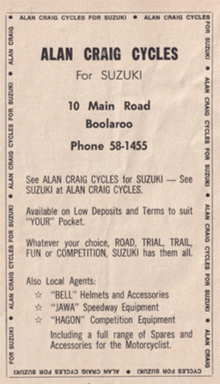
Alan decided to sponsor and mentor young riders around the Newcastle region, not only enabling him to pass on his knowledge toa younger generation, but also for the financial reason that the parents would get involved in the careers of their children and be ready to purchase new models each year, whether it be a new 80cc, 125cc or 250cc.
Alan gained huge satisfaction by watching these young riders improve. Some of his charges gained local, State, National and even International status due to his involvement and recognition of talent at an early age in the sport.
Alan’s role in promoting also involved motor cross sponsoring and supporting many young competitors. One of Alan’s more successful charges was the then world champion Chad Reed. Alan tackled his new ventures head on – promoting and organising supercross meetings at Newcastle Showground, Heddon Greta and Singleton Showground. These events attracted high caliber international supercross riders. Alan has always said that Newcastle and the coal fields has produced numerous world class riders due to the many thriving junior clubs – Raymond Terrace, Kurri Kurri, Gwandalan and Toronto. Casey Stoner was a Kurri junior who was only 17 when he started his Moto GP career.
Alan Craig has gained a level of achievement in his lifetime that most of us would only dream of - motorcycle design, builder, racer, entrepreneur, visionary, sponsor and patron of numerous young riders from the Hunter Valley.
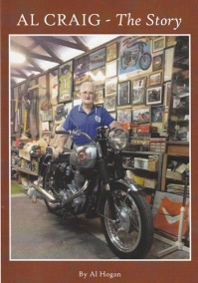
Alan was not scared to have a go at anything that he thought was worthwhile and in the interest of motor sport within the Hunter region.
Today, Alan is President of the Newcastle Classic Motorcycle Club, which he joined in 1990.
I have written only a very small part of Alan Craig’s life. If you would like to learn more about this amazing man, Al Hogan has written a biography of his life – “Al Craig – The Story” (See photograph) Copies are available by contacting Alan Craig – 0412 801 017.
Al Hogan has created a memorable archive of someone’s life that would be otherwise lost forever.

Respect for Alan
I have nothing but respect for Alan. Dad and I first met Craigy at his motorcycle shop Boolaroo. We would purchase speedway equipment from him around the time Jerilderie Park had commenced operation. Of course ,he directed the solo section of those meetings with an iron fist. It was Alan who gave me my first chance to race as a junior and also run a weekly practice night often attended by riders from the Hunter, Sydney and other areas.
Newcastle Speedway Riders Association meetings were held at Craigy’s shop. Dad and I would often go to these often heated discussions.
Alan was very instrumental in advancing motorcycle sport in the Hunter. I actually bumped into him at Bob Valentine’s funeral and for a bloke who is now ninety, he still has what seems enough enthusiasm to carry on his involvement in motorcycling. Stuart Mountford
Alan was a major promoter and supported many speedway, short circuit and motorcross riders over the years from the Hunter Valley. He was the owner of a Suzuki franchise and sold speedway parts at Boolaroo.
He is well known, respected and a true gentleman in the motorcycling industry. Peter Fitzpatrick
I would like to thank the following people for providing information for this article. Alan Craig, Al Hogan, Peter Fitzpatrick, Stuart Mountford, Terry McKenna and Terry Sutherland.

