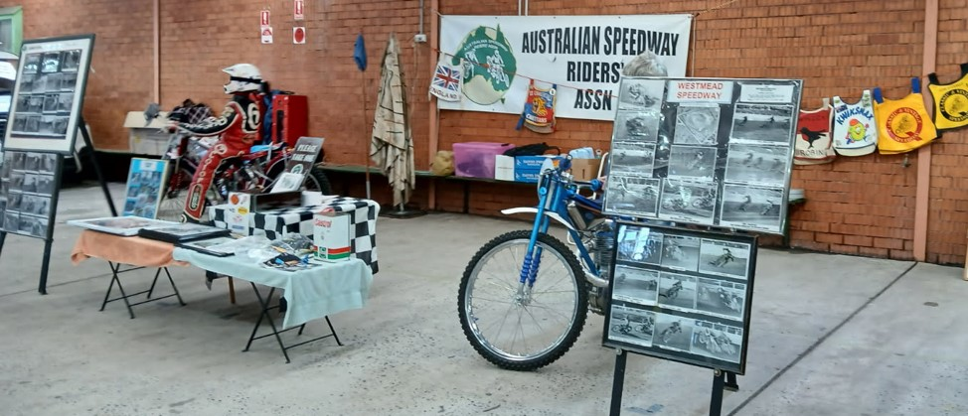

**Bulli Antique Motorcycle Weekend – 22-23 August 2025** – Bill Powell

The ASRA display at the annual Bulli NSW Antique Motorcycle weekend was, once again, a marvellous success, with thousands of people viewing and remarking on our good display of machines and memorabilia over two days. This event is always professionally organised with numerous technical seminars and historic motorcycle club displays. On the Saturday a motorcycle auction was held, along with a swap meet.

It was so pleasing to see the interest shown in our photo board display. One board was displaying photos of the 1950s Sydney Showground speedway and the other showed 1960s Westmead racing. Quite a large number of people took photos of these boards.

This year’s key speaker was Darrin Treloar, the multiple Australian speedway sidecar champion. The organisers introduced him as the world’s greatest ever sidecar racer.

Thank you to ASRA Members Grant Ellis (*Billy Sanders Weslake tribute bike*), Allan Ekin (*Jim Airey 2-valve Jawa tribute bike*), Greg Cameron (*Bob Baker 2-valve Jawa, with mannequin rider and his beautifully restored 500cc BSA Slider*). Thanks also to Ken Carrat and Dave Clifton for their assistance over the weekend.

Bill Powell – ASRA Event Co-ordinator